QUESTION : 1
Create a table called Restaurants with columns: id, name, cuisine, rating, and city. Insert at least 5 sample records representing real or fictional restaurants you might find on Zomato :

TABLE :
CREATE TABLE Restaurants(
id INT,
name VARCHAR(100),
cuisine VARCHAR(50),
rating DECIMAL(2,1),
city VARCHAR(50),
PRIMARY KEY(id)
);

VALUES :
INSERT INTO Restaurants(id,name,cuisine,rating,city)
VALUES
(1,'Swagat','North indian',4.5,'Ahmedabad'),
(2,'Swadisht','South indian',4.2,'Surat'),
(3,'Pizza Hub','Italian',3.9,'Ahmedabad'),
(4,'Dragon Wok','Chinese',4.4,'Rajkot'),
(5,'Royal Spice','Gujarati',3.7,'Surat');
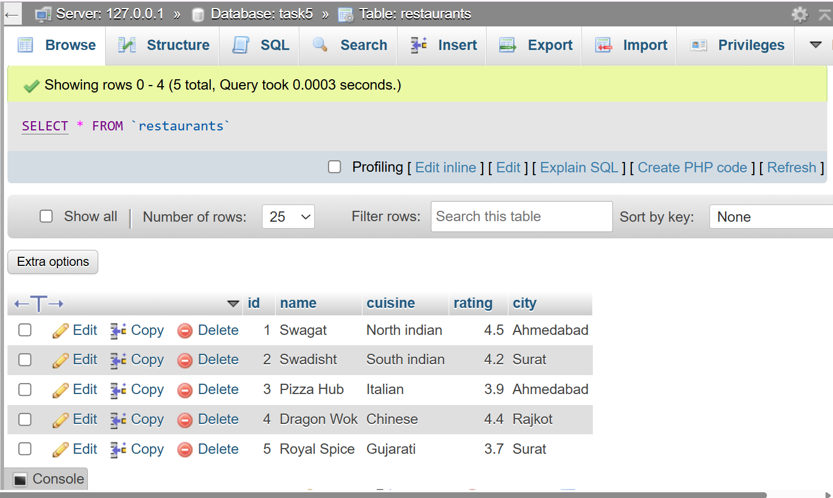
QUESTION : 2
Write a SQL query to find all restaurants in the Restaurants table that have a rating greater than 4.0 and are located in either 'Ahmedabad' or 'Surat :

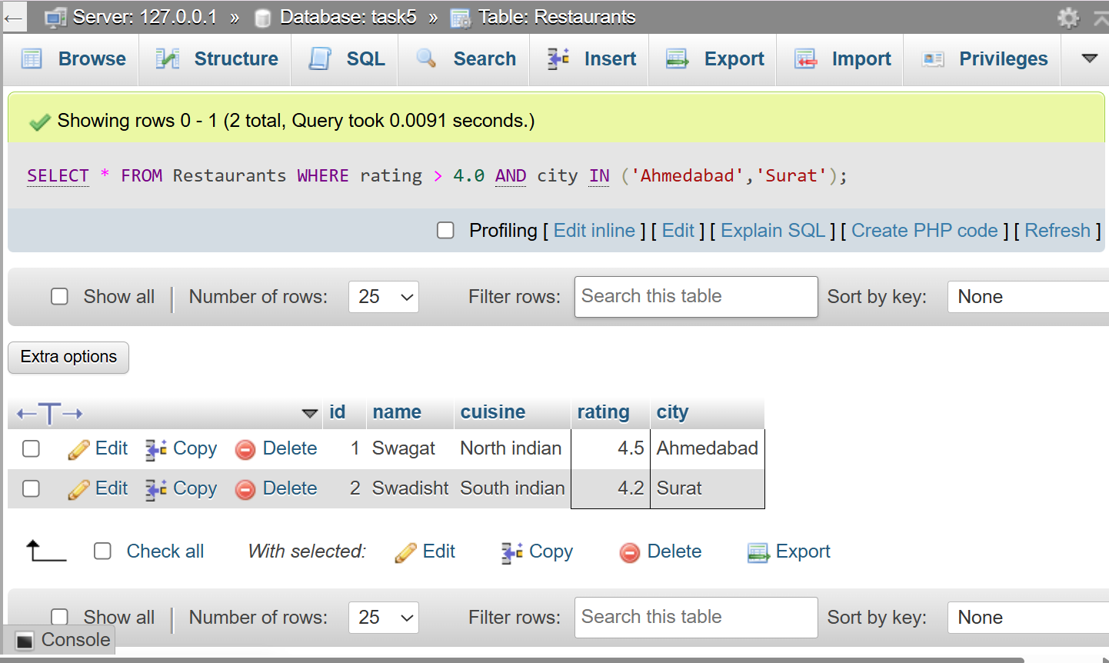
SELECT * FROM Restaurants WHERE rating > 4.0 AND city IN ('Ahmedabad','Surat');
QUESTION : 3
Using the LIKE operator, write a query to select all restaurants whose names start with 'Swa' (for example, 'Swagat', 'Swadisht') from the Restaurants Table <br><br><em><strong>Hint:</strong> Use LIKE 'Swa%'.</em> :

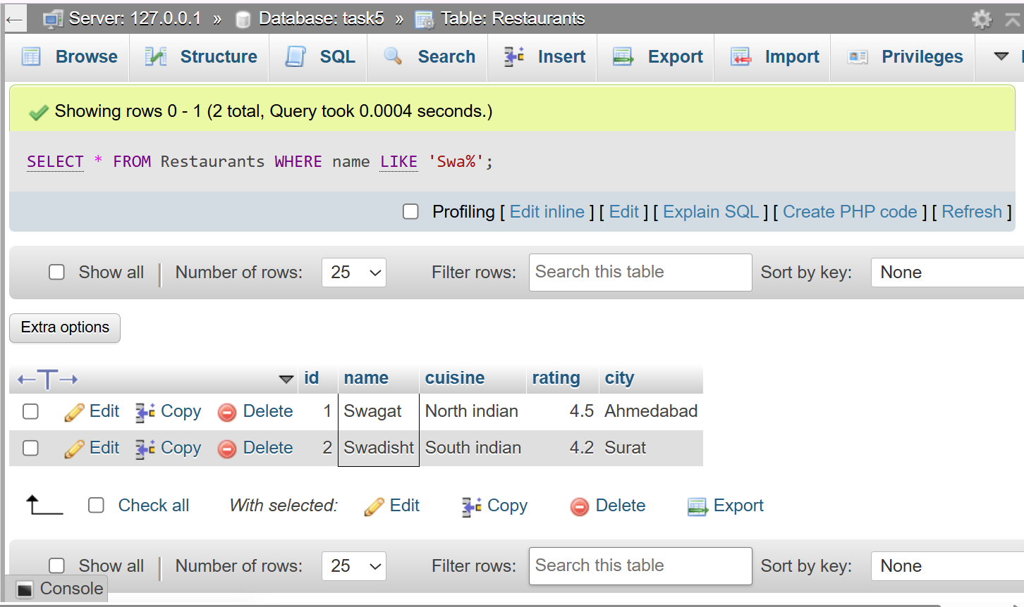
SELECT * FROM Restaurants WHERE name LIKE 'Swa%' ;

QUESTION : 4
Write a SQL query using the BETWEEN keyword to find all restaurants in the Restaurants table with a rating between 3.5 and 4.5 (inclusive) :

SELECT * FROM Restaurants WHERE rating BETWEEN 3.5 AND 4.5;

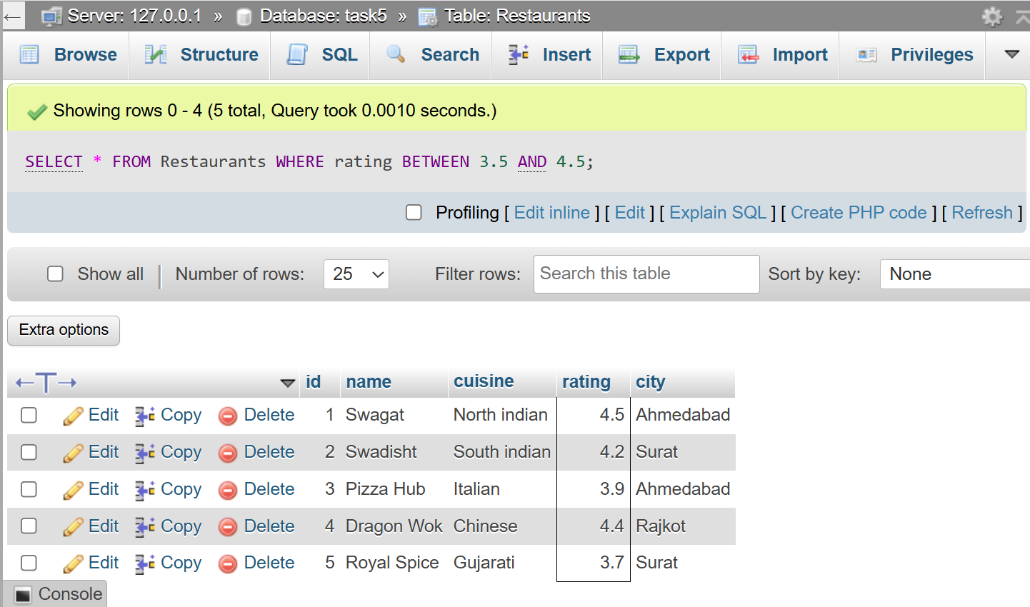
QUESTION : 5
Write a query to find all restaurants whose cuisine is either 'Chinese', 'Italian', or 'South Indian' using the IN operator :
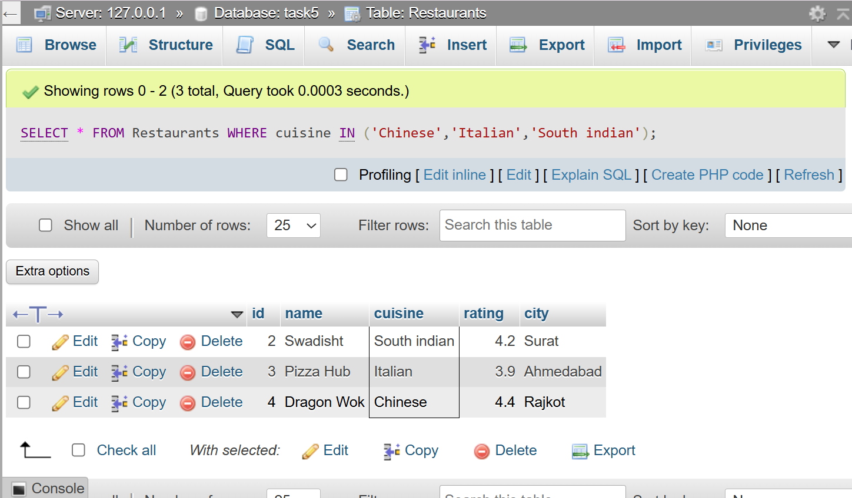
SELECT * FROM Restaurants WHERE cuisine IN ('Chinese','Italian','South indian');

